# PLSQL_Exercises

### Exercise 1: Control Structures

#### Scenario 1:

DELIMITER $$

CREATE PROCEDURE ApplyInterestDiscount() BEGIN

DECLARE done INT DEFAULT FALSE;

DECLARE v_custID INT;

DECLARE v_dob DATE;

DECLARE cur CURSOR FOR SELECT CustomerID, DOB FROM Customers; DECLARE CONTINUE HANDLER FOR NOT FOUND SET done = TRUE

OPEN cur; read_loop: LOOP

FETCH cur INTO v_custID, v_dob;

IF done THEN

LEAVE read_loop;

END IF

IF TIMESTAMPDIFF(YEAR, v_dob, CURDATE()) > 60 THEN

UPDATE Loans

SET InterestRate = InterestRate - 1 WHERE CustomerID = v_custID;

SELECT CONCAT('Applied 1% discount to CustomerID: ', v_custID) AS Message; END IF;

END LOOP;

CLOSE cur;

END$$ DELIMITER ;

CALL ApplyInterestDiscount(); USE BankDB;

CALL ApplyInterestDiscount();

# output

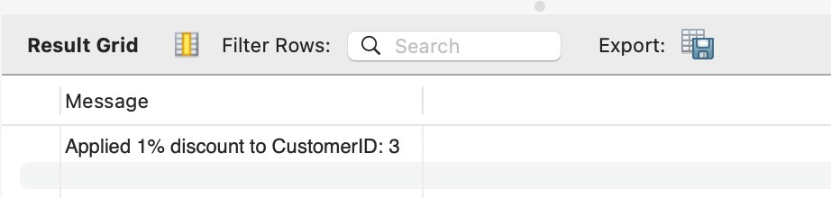

##### Scenario 2:

DROP PROCEDURE IF EXISTS UpdateVIPStatus; DELIMITER $$

CREATE PROCEDURE UpdateVIPStatus() BEGIN

UPDATE Customers

SET IsVIP = CASE WHEN Balance > 10000 THEN TRUE ELSE FALSE END;

END$$ DELIMITER ;

SET SQL_SAFE_UPDATES = 0;

CALL UpdateVIPStatus(); DELIMITER $$

CREATE PROCEDURE UpdateVIPStatus()

BEGIN

UPDATE Customers

SET IsVIP = CASE WHEN Balance > 10000 THEN TRUE ELSE FALSE END;

END$$ DELIMITER ;

CALL UpdateVIPStatus();

SELECT CustomerID, Name, Balance, IsVIP FROM Customers;

# output

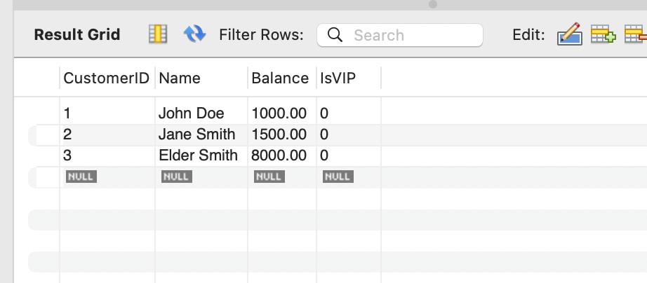

### Scenario 3:

DROP PROCEDURE IF EXISTS UpdateVIPStatus; DELIMITER $$

CREATE PROCEDURE UpdateVIPStatus() BEGIN

-- Update IsVIP flag: TRUE if balance > 10000, else FALSE UPDATE Customers

SET IsVIP = CASE WHEN Balance > 10000 THEN TRUE ELSE FALSE END;

END$$ DELIMITER ;

CALL UpdateVIPStatus();

SELECT CustomerID, Name, Balance, IsVIP FROM Customers;

Output

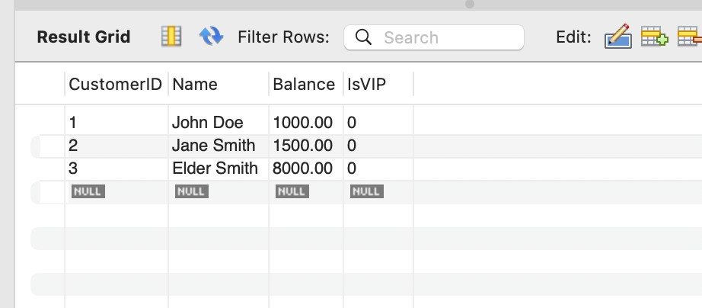

## Exercise 2: Error Handling

##### Scenario 1:

DROP PROCEDURE IF EXISTS SafeTransferFunds; DELIMITER $$

CREATE PROCEDURE SafeTransferFunds( IN p_fromAccount INT,

IN p_toAccount INT,

IN p_amount DECIMAL(10,2)

)

BEGIN

DECLARE insufficient_funds BOOL DEFAULT FALSE; DECLARE EXIT HANDLER FOR SQLEXCEPTION

BEGIN

ROLLBACK;

SELECT 'Error: Transfer failed. Transaction rolled back.' AS ErrorMessage; END;

START TRANSACTION;

-- Check if source has sufficient funds

IF (SELECT Balance FROM Accounts WHERE AccountID = p_fromAccount) < p_amount THEN SET insufficient_funds = TRUE;

ELSE

-- Deduct from source account UPDATE Accounts

SET Balance = Balance - p_amount

WHERE AccountID = p_fromAccount;

-- Add to destination account

UPDATE Accounts

SET Balance = Balance + p_amount WHERE AccountID = p_toAccount; COMMIT;

END IF;

IF insufficient_funds THEN ROLLBACK;

SELECT 'Error: Insufficient funds in source account.' AS ErrorMessage; ELSE

SELECT 'Success: Transfer completed.' AS SuccessMessage; END IF;

END$$

DELIMITER ;

CALL SafeTransferFunds(1, 2, 500.00);

# output

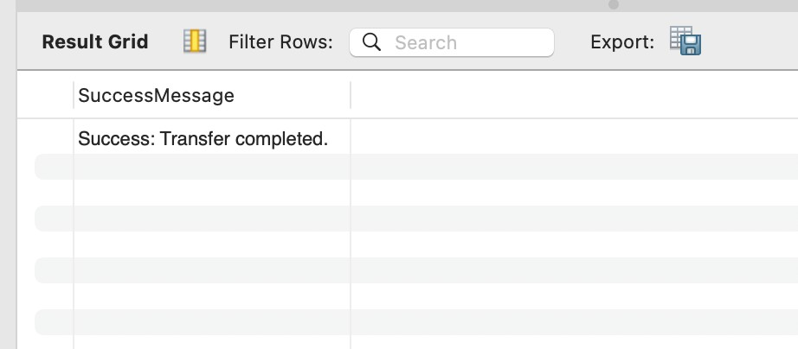

##### Scenario 2:

DROP PROCEDURE IF EXISTS UpdateSalary; DELIMITER $$

CREATE PROCEDURE UpdateSalary(

IN p_empID INT,

IN p_percent DECIMAL(5,2)

)

BEGIN

-- Declare variables first DECLARE v_exists INT;

-- Then declare handlers

DECLARE EXIT HANDLER FOR SQLEXCEPTION BEGIN

ROLLBACK;

SELECT CONCAT('Error: Could not update salary for employee ID ', p_empID) AS ErrorMessage;

END;

-- Check if employee exists

SELECT COUNT(*) INTO v_exists FROM Employees WHERE EmployeeID = p_empID; IF v_exists = 0 THEN

SELECT CONCAT('Error: Employee ID ', p_empID, ' does not exist.') AS ErrorMessage; ELSE

START TRANSACTION;

-- Update salary UPDATE Employees

SET Salary = Salary + (Salary * p_percent / 100)

WHERE EmployeeID = p_empID; COMMIT;

SELECT CONCAT('Success: Salary updated for employee ID ', p_empID) AS SuccessMessage;

END IF;

END$$ DELIMITER ;

CALL UpdateSalary(101, 10);

# output

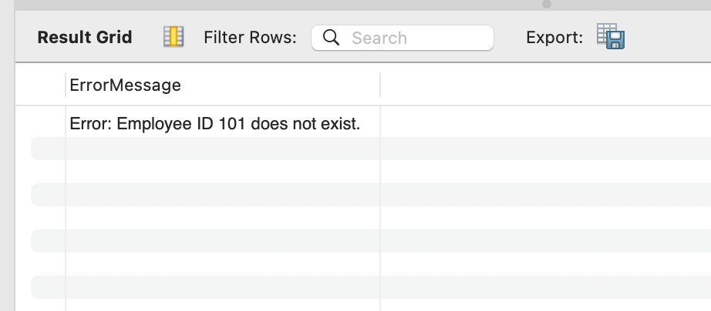

##### Scenario 3:

DROP PROCEDURE IF EXISTS AddNewCustomer; DELIMITER $$

CREATE PROCEDURE AddNewCustomer(

IN p_customerID INT,

IN p_name VARCHAR(100),

IN p_dob DATE,

IN p_balance DECIMAL(10,2)

)

BEGIN

-- Declare variables DECLARE v_exists INT;

-- Exception handler

DECLARE EXIT HANDLER FOR SQLEXCEPTION BEGIN

SELECT CONCAT('Error: Could not insert customer ID ', p_customerID) AS ErrorMessage; END;

-- Check if the customer already exists

SELECT COUNT(*) INTO v_exists FROM Customers WHERE CustomerID = p_customerID; IF v_exists > 0 THEN

SELECT CONCAT('Error: Customer with ID ', p_customerID, ' already exists.') AS ErrorMessage;

ELSE

-- Insert the new customer

INSERT INTO Customers (CustomerID, Name, DOB, Balance) VALUES (p_customerID, p_name, p_dob, p_balance);

SELECT CONCAT('Success: Customer ID ', p_customerID, ' added successfully.') AS SuccessMessage;

END IF;

END$$ DELIMITER ;

# output

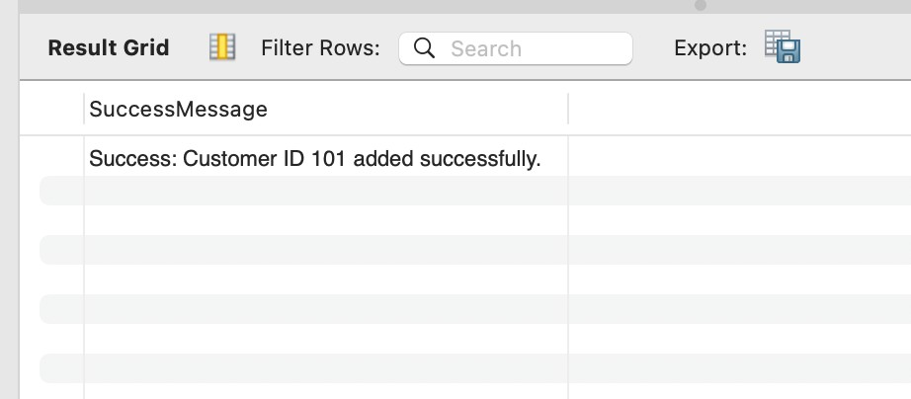

#### Exercise 3: Stored Procedures Scenario 1:

DROP PROCEDURE IF EXISTS ProcessMonthlyInterest; DELIMITER $$

CREATE PROCEDURE ProcessMonthlyInterest() BEGIN

-- Update all savings accounts with 1% interest UPDATE Accounts

SET Balance = Balance + (Balance * 0.01)

WHERE AccountType = 'Savings';

SELECT 'Monthly interest processed successfully.' AS Message; END$$

DELIMITER ;

CALL ProcessMonthlyInterest();

output

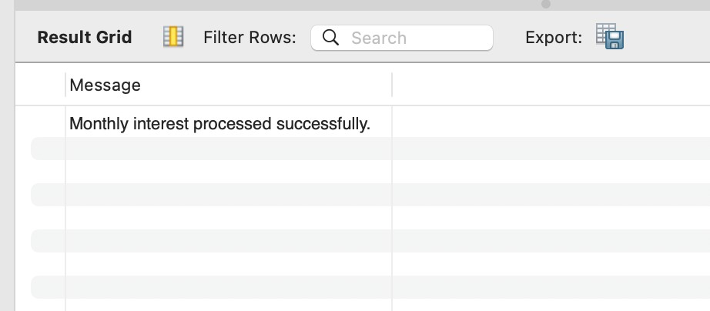

##### Scenario 2:

DROP PROCEDURE IF EXISTS UpdateEmployeeBonus; DELIMITER $$

CREATE PROCEDURE UpdateEmployeeBonus(

IN p_department VARCHAR(100), IN p_bonusPercent DECIMAL(5,2)

)

BEGIN

-- Apply bonus to employees in the specified department UPDATE Employees

SET Salary = Salary + (Salary * p_bonusPercent / 100)

WHERE Department = p_department;

SELECT CONCAT('Bonus of ', p_bonusPercent, '% applied to department ', p_department) AS Message;

END$$ DELIMITER ;

CALL UpdateEmployeeBonus('IT', 5.0);

# output

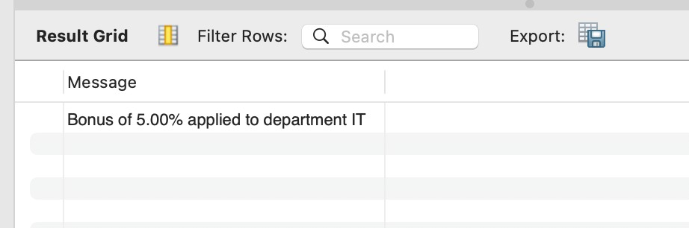

#### Scenario 3:

DROP PROCEDURE IF EXISTS TransferFunds; DELIMITER $$

CREATE PROCEDURE TransferFunds( IN p_fromAccount INT,

IN p_toAccount INT,

IN p_amount DECIMAL(10,2)

)

BEGIN

DECLARE v_balance DECIMAL(10,2);

-- Get balance of source account

SELECT Balance INTO v_balance FROM Accounts WHERE AccountID = p_fromAccount;

IF v_balance < p_amount THEN

SELECT 'Error: Insufficient balance.' AS ErrorMessage; ELSE

START TRANSACTION;

-- Deduct from source UPDATE Accounts

SET Balance = Balance - p_amount WHERE AccountID = p_fromAccount;

-- Add to destination UPDATE Accounts

SET Balance = Balance + p_amount WHERE AccountID = p_toAccount;

COMMIT;

SELECT 'Success: Funds transferred.' AS SuccessMessage; END IF;

END$$

DELIMITER ;

# output

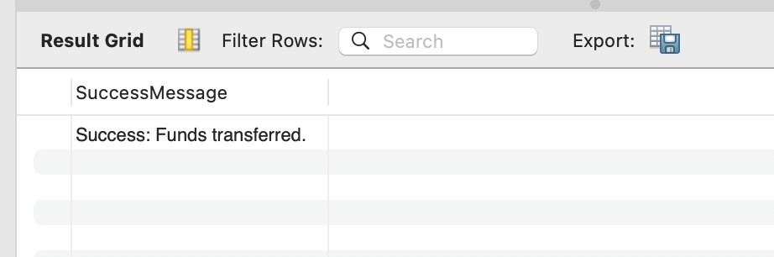

#### Exercise 4: Functions

##### Scenario 1:

DROP FUNCTION IF EXISTS CalculateAge; DELIMITER $$

CREATE FUNCTION CalculateAge(p_dob DATE) RETURNS INT

###### DETERMINISTIC BEGIN

RETURN TIMESTAMPDIFF(YEAR, p_dob, CURDATE());

###### END$$ DELIMITER ;

SELECT CalculateAge('2000-05-21') AS Age;

# output

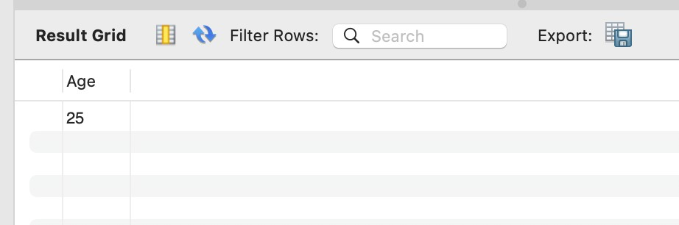

##### Scenario 2:

DROP FUNCTION IF EXISTS CalculateMonthlyInstallment; DELIMITER $$

CREATE FUNCTION CalculateMonthlyInstallment(

p_amount DECIMAL(10,2), p_annualRate DECIMAL(5,2), p_years INT

)

RETURNS DECIMAL(10,2) DETERMINISTIC

BEGIN

DECLARE r DECIMAL(10,6); -- monthly rate DECLARE n INT; -- total number of months DECLARE emi DECIMAL(10,2);

SET r = p_annualRate / (12 * 100); SET n = p_years * 12;

SET emi = (p_amount * r * POW(1 + r, n)) / (POW(1 + r, n) - 1);

RETURN emi;

END$$

DELIMITER ;

SELECT CalculateMonthlyInstallment(100000, 10, 5) AS EMI;

# output

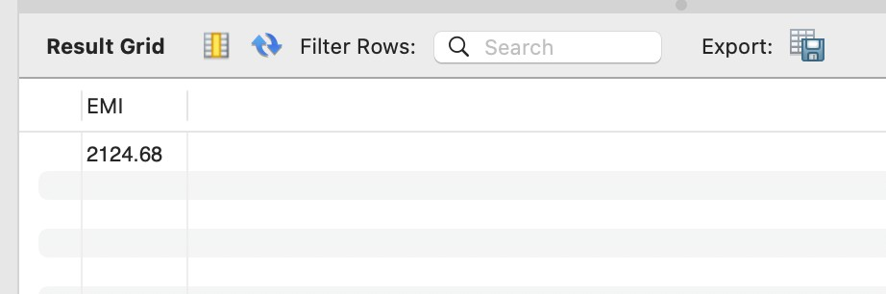

Scenario 3:

DROP FUNCTION IF EXISTS HasSufficientBalance; DELIMITER $$

CREATE FUNCTION HasSufficientBalance( p_accountID INT,

p_amount DECIMAL(10,2)

)

###### RETURNS BOOLEAN DETERMINISTIC BEGIN

DECLARE v_balance DECIMAL(10,2); SELECT Balance INTO v_balance FROM Accounts

WHERE AccountID = p_accountID; RETURN v_balance >= p_amount;

###### END$$ DELIMITER ;

SELECT HasSufficientBalance(101, 500.00) AS IsEnough;

# output

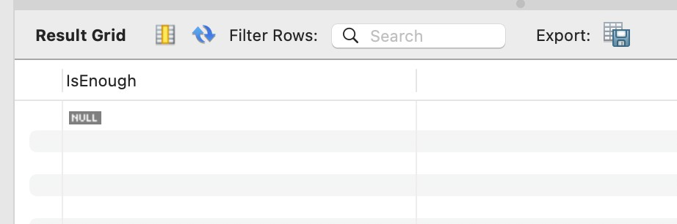

### Exercise 5: Triggers

Scenario 1

DROP TRIGGER IF EXISTS UpdateCustomerLastModified; DELIMITER $$

CREATE TRIGGER UpdateCustomerLastModified

BEFORE UPDATE ON Customers FOR EACH ROW

BEGIN

SET NEW.LastModified = NOW(); END$$

DELIMITER ;

SELECT CustomerID, LastModified FROM Customers WHERE CustomerID = 101;

output

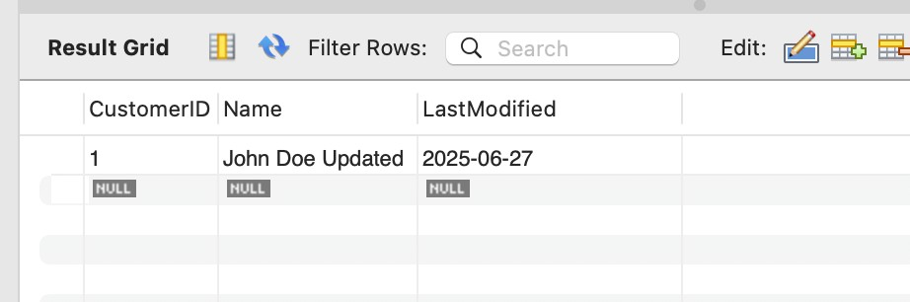

### Scenario 2:

DELIMITER $$

CREATE TRIGGER LogTransaction AFTER INSERT ON Transactions FOR EACH ROW

BEGIN

INSERT INTO AuditLog (TransactionID, AccountID, Amount, TransactionDate, Action)

VALUES (NEW.TransactionID, NEW.AccountID, NEW.Amount, NEW.TransactionDate, 'INSERT'); END$$

DELIMITER ;

CREATE TABLE AuditLog (

AuditID INT AUTO_INCREMENT PRIMARY KEY,

TransactionID INT, AccountID INT,

Amount DECIMAL(15,2),

TransactionDate DATE, Action VARCHAR(20),

LogTimestamp TIMESTAMP DEFAULT CURRENT_TIMESTAMP

);

INSERT INTO Transactions (TransactionID, AccountID, Amount, TransactionDate) VALUES (1004, 101, 100.00, CURDATE());

SELECT * FROM AuditLog WHERE TransactionID = 1004;

# output

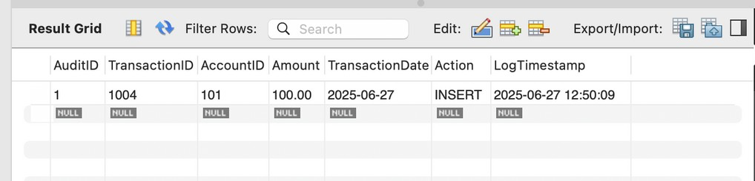

### Scenario 3:

DELIMITER $$

CREATE TRIGGER CheckTransactionRules BEFORE INSERT ON Transactions

FOR EACH ROW

BEGIN

DECLARE current_balance DECIMAL(15,2);

-- Get current balance from Accounts table

SELECT Balance INTO current_balance FROM Accounts WHERE AccountID = NEW.AccountID;

-- Check deposit amount must be positive IF NEW.Amount <= 0 THEN

SIGNAL SQLSTATE '45000' SET MESSAGE_TEXT = 'Error: Deposit or withdrawal amount must be positive';

END IF;

-- If withdrawal (assume negative amount means withdrawal) IF NEW.Amount < 0 THEN

-- Ensure withdrawal does not exceed current balance IF current_balance < ABS(NEW.Amount) THEN

SIGNAL SQLSTATE '45000' SET MESSAGE_TEXT = 'Error: Insufficient balance for withdrawal';

END IF;

END IF;

END$$

DELIMITER ;

INSERT INTO Transactions (TransactionID, AccountID, Amount, TransactionDate) VALUES (1005, 101, 200.00, CURDATE());

INSERT INTO Transactions (TransactionID, AccountID, Amount, TransactionDate) VALUES (1006, 101, -50.00, CURDATE());

INSERT INTO Transactions (TransactionID, AccountID, Amount, TransactionDate) VALUES (1007, 101, -100000.00, CURDATE());

# output



### Exercise 6: Cursors

##### Scenario 1:

DELIMITER //

CREATE PROCEDURE GenerateMonthlyStatements() BEGIN

DECLARE done INT DEFAULT FALSE;

DECLARE v_CustomerID INT; DECLARE v_TransactionID INT; DECLARE v_Amount DECIMAL(10,2);

DECLARE v_TransactionDate DATE; DECLARE cur_transactions CURSOR FOR

SELECT a.CustomerID, t.TransactionID, t.Amount, t.TransactionDate FROM Transactions t

JOIN Accounts a ON t.AccountID = a.AccountID

WHERE DATE_FORMAT(t.TransactionDate, '%Y-%m') = DATE_FORMAT(CURDATE(), '%Y-

%m');

DECLARE CONTINUE HANDLER FOR NOT FOUND SET done = TRUE;

OPEN cur_transactions; read_loop: LOOP

FETCH cur_transactions INTO v_CustomerID, v_TransactionID, v_Amount, v_TransactionDate;

IF done THEN

LEAVE read_loop;

END IF;

SELECT CONCAT('Customer ', v_CustomerID, ' Transaction ', v_TransactionID,

' Amount: ', v_Amount,

' Date: ', DATE_FORMAT(v_TransactionDate, '%d-%b-%Y')) AS Statement; END LOOP;

CLOSE cur_transactions;

END;

// DELIMITER ;

DROP PROCEDURE IF EXISTS GenerateMonthlyStatements; CALL GenerateMonthlyStatements();

# output

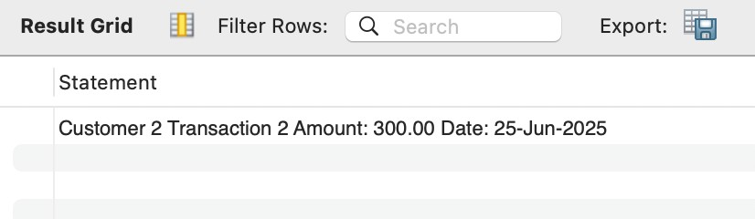

##### Scenario 2:

DELIMITER //

CREATE PROCEDURE ApplyAnnualFee() BEGIN

DECLARE done INT DEFAULT FALSE;

DECLARE v_AccountID INT; DECLARE v_Balance DECIMAL(10,2);

DECLARE cur_accounts CURSOR FOR

SELECT AccountID, Balance FROM Accounts;

DECLARE CONTINUE HANDLER FOR NOT FOUND SET done = TRUE;

OPEN cur_accounts; read_loop: LOOP

FETCH cur_accounts INTO v_AccountID, v_Balance; IF done THEN

LEAVE read_loop;

END IF;

-- Deduct fee if balance is sufficient

IF v_Balance >= 100 THEN UPDATE Accounts

SET Balance = Balance - 100 WHERE AccountID = v_AccountID;

ELSE

-- Optional: handle insufficient balance scenario

SELECT CONCAT('Account ', v_AccountID, ' has insufficient balance for annual fee deduction.') AS WarningMessage;

END IF;

END LOOP;

CLOSE cur_accounts;

SELECT 'Annual fee applied to all eligible accounts.' AS Message; END;

// DELIMITER ;

CALL ApplyAnnualFee();

# output

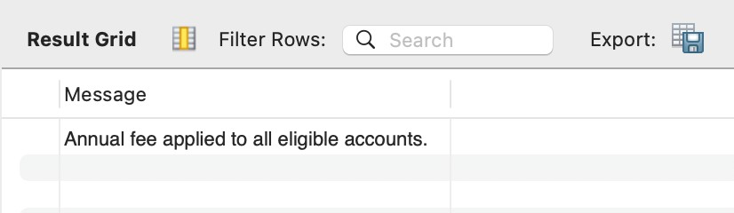

### Scenario 3:

DELIMITER //

CREATE PROCEDURE UpdateLoanInterestRates() BEGIN

DECLARE done INT DEFAULT FALSE;

DECLARE v_LoanID INT;

DECLARE v_InterestRate DECIMAL(5,2); DECLARE v_LoanAmount DECIMAL(10,2); DECLARE cur_loans CURSOR FOR

SELECT LoanID, InterestRate, LoanAmount FROM Loans; DECLARE CONTINUE HANDLER FOR NOT FOUND SET done = TRUE;

OPEN cur_loans; read_loop: LOOP

FETCH cur_loans INTO v_LoanID, v_InterestRate, v_LoanAmount; IF done THEN

LEAVE read_loop;

END IF;

IF v_LoanAmount > 50000 THEN

UPDATE Loans

SET InterestRate = v_InterestRate + 0.5 WHERE LoanID = v_LoanID;

ELSE

UPDATE Loans

SET InterestRate = v_InterestRate + 0.2 WHERE LoanID = v_LoanID;

END IF;

END LOOP;

CLOSE cur_loans;

SELECT 'Loan interest rates updated according to the new policy.' AS Message; END;

// DELIMITER ;

CALL UpdateLoanInterestRates();

# output

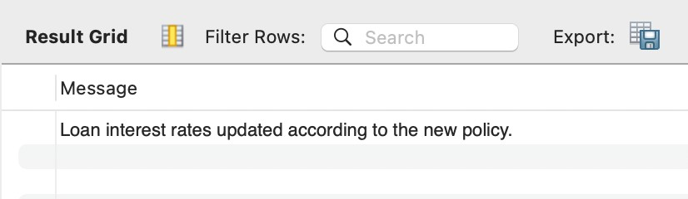

#### Exercise 7: Packages

##### Scenario 1:

DELIMITER //

CREATE PROCEDURE CustomerManagement_AddCustomer ( IN p_Name VARCHAR(100),

IN p_Email VARCHAR(100),

IN p_Balance DECIMAL(10,2)

)

BEGIN

INSERT INTO Customers (Name, Email, Balance) VALUES (p_Name, p_Email, p_Balance);

END;

// DELIMITER ;

DELIMITER //

CREATE PROCEDURE CustomerManagement_UpdateCustomer ( IN p_CustomerID INT,

IN p_Email VARCHAR(100)

)

BEGIN

UPDATE Customers SET Email = p_Email

WHERE CustomerID = p_CustomerID;

END;

// DELIMITER ;

DELIMITER //

CREATE FUNCTION CustomerManagement_GetBalance(p_CustomerID INT) RETURNS DECIMAL(10,2)

DETERMINISTIC

BEGIN

DECLARE v_balance DECIMAL(10,2);

SELECT Balance INTO v_balance FROM Customers WHERE CustomerID = p_CustomerID; RETURN v_balance;

END;

// DELIMITER ; SELECT

TABLE_NAME,

CONSTRAINT_NAME, COLUMN_NAME,

REFERENCED_TABLE_NAME, REFERENCED_COLUMN_NAME FROM

INFORMATION_SCHEMA.KEY_COLUMN_USAGE WHERE

REFERENCED_TABLE_NAME = 'Customers'

AND REFERENCED_COLUMN_NAME = 'CustomerID' AND CONSTRAINT_SCHEMA = 'BankDB';

ALTER TABLE Loans DROP FOREIGN KEY loans_ibfk_1;

ALTER TABLE Customers MODIFY CustomerID INT NOT NULL AUTO_INCREMENT; ALTER TABLE Loans

ADD CONSTRAINT loans_ibfk_1 FOREIGN KEY (CustomerID)

REFERENCES Customers(CustomerID);

CALL CustomerManagement_AddCustomer('Hemavathy', ['hema@email.com',](mailto:%27hema@email.com) 6000); SELECT * FROM Customers WHERE Email = ['hema@email.com';](mailto:%27hema@email.com)

# output

## Scenario 2:

DROP PROCEDURE IF EXISTS EmployeeManagement_HireEmployee;

DROP PROCEDURE IF EXISTS EmployeeManagement_UpdateEmployee;

DROP FUNCTION IF EXISTS EmployeeManagement_CalculateAnnualSalary; DELIMITER $$

CREATE FUNCTION EmployeeManagement_CalculateAnnualSalary(

p_empID INT

) RETURNS DECIMAL(15,2) READS SQL DATA

BEGIN

DECLARE v_salary DECIMAL(10,2);

SELECT Salary INTO v_salary FROM Employees WHERE EmployeeID = p_empID; RETURN v_salary * 12;

END $$ DELIMITER ;

SELECT EmployeeManagement_CalculateAnnualSalary(101) AS AnnualSalary;

SELECT Salary FROM Employees WHERE EmployeeID = 101; DELIMITER $$

CREATE FUNCTION EmployeeManagement_CalculateAnnualSalary(p_empID INT)

RETURNS DECIMAL(15,2) DETERMINISTIC

READS SQL DATA BEGIN

DECLARE v_salary DECIMAL(10,2);

SELECT Salary INTO v_salary FROM Employees WHERE EmployeeID = p_empID; IF v_salary IS NULL THEN

RETURN 0; -- or NULL if you prefer ELSE

RETURN v_salary * 12; END IF;

END$$ DELIMITER ;

DROP FUNCTION IF EXISTS EmployeeManagement_CalculateAnnualSalary; DELIMITER $$

CREATE FUNCTION EmployeeManagement_CalculateAnnualSalary(p_empID INT)

RETURNS DECIMAL(15,2) DETERMINISTIC

READS SQL DATA BEGIN

DECLARE v_salary DECIMAL(10,2);

SELECT Salary INTO v_salary FROM Employees WHERE EmployeeID = p_empID; IF v_salary IS NULL THEN

RETURN 0; -- or NULL if you prefer

ELSE

RETURN v_salary * 12; END IF;

END$$ DELIMITER ;

SELECT EmployeeManagement_CalculateAnnualSalary(101) AS AnnualSalary;

# output

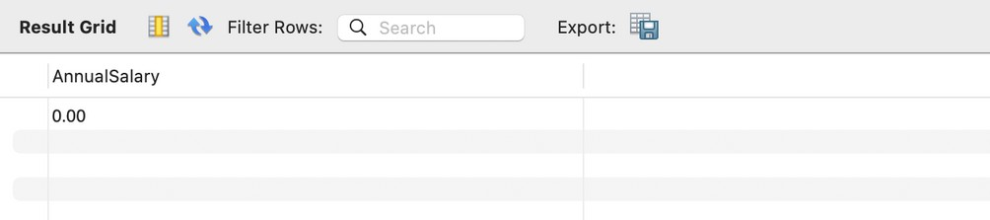

### Scenario 3:

DELIMITER $$

CREATE PROCEDURE AccountOperations_OpenAccount( IN p_CustomerID INT,

IN p_AccountType VARCHAR(50),

IN p_InitialDeposit DECIMAL(15,2)

)

BEGIN

INSERT INTO Accounts (CustomerID, AccountType, Balance, OpenDate) VALUES (p_CustomerID, p_AccountType, p_InitialDeposit, CURDATE()); SELECT 'Account opened successfully.' AS Message;

END$$ DELIMITER ;

-- Procedure to close an account DELIMITER $$

CREATE PROCEDURE AccountOperations_CloseAccount( IN p_AccountID INT

)

BEGIN

DELETE FROM Accounts WHERE AccountID = p_AccountID; SELECT 'Account closed successfully.' AS Message;

END$$ DELIMITER ; DELIMITER $$

CREATE FUNCTION AccountOperations_GetTotalBalance( p_CustomerID INT

)

RETURNS DECIMAL(15,2) DETERMINISTIC

READS SQL DATA

BEGIN

DECLARE total_balance DECIMAL(15,2);

SELECT IFNULL(SUM(Balance), 0) INTO total_balance FROM Accounts

WHERE CustomerID = p_CustomerID;

RETURN total_balance; END$$

DELIMITER ;

CALL AccountOperations_OpenAccount(101, 'Savings', 1000.00); ALTER TABLE Accounts ADD COLUMN OpenDate DATE; DELIMITER $$

CREATE PROCEDURE AccountOperations_OpenAccount( IN p_CustomerID INT,

IN p_AccountType VARCHAR(50), IN p_InitialDeposit DECIMAL(15,2)

)

BEGIN

INSERT INTO Accounts (CustomerID, AccountType, Balance) VALUES (p_CustomerID, p_AccountType, p_InitialDeposit); SELECT 'Account opened successfully.' AS Message;

END$$ DELIMITER ;

-- Step 1: Drop the foreign key constraint temporarily

ALTER TABLE Transactions DROP FOREIGN KEY transactions_ibfk_1;

-- Step 2: Drop the primary key on Accounts.AccountID ALTER TABLE Accounts DROP PRIMARY KEY;

-- Step 3: Modify AccountID to AUTO_INCREMENT PRIMARY KEY

ALTER TABLE Accounts MODIFY AccountID INT NOT NULL AUTO_INCREMENT PRIMARY KEY;

-- Step 4: Recreate the foreign key constraint ALTER TABLE Transactions

ADD CONSTRAINT transactions_ibfk_1

FOREIGN KEY (AccountID) REFERENCES Accounts(AccountID);

INSERT INTO Accounts (CustomerID, AccountType, Balance, OpenDate) VALUES (101, 'Savings', 1000.00, CURDATE());

ALTER TABLE Transactions MODIFY TransactionID INT NOT NULL AUTO_INCREMENT PRIMARY KEY;

INSERT INTO Transactions (AccountID, Amount, TransactionDate) VALUES (LAST_INSERT_ID(), 500.00, CURDATE());

SHOW CREATE TABLE Transactions;

ALTER TABLE Transactions MODIFY TransactionID INT NOT NULL AUTO_INCREMENT; INSERT INTO Transactions (AccountID, Amount, TransactionDate, TransactionType) VALUES (101, 500.00, CURDATE(), 'Deposit');

SELECT * FROM Transactions WHERE AccountID = 101 ORDER BY TransactionID DESC LIMIT 1;

output

